VISUAL GUIDE TO SETUP ONLINE GAME
- Download and install Node.js (server infrastructure) and Cloudflared (connection tunnel):
- Node.js: Node.js — Download Node.js®
- Cloudflared: Releases · cloudflare/cloudflared Select the version needed for your system, rename the downloaded file to cloudflared.exe. For windows users:
https://github.com/cloudflare/cloudflared/releases/download/2026.6.1/cloudflared-windows-amd64.exe

- Keep the following files in your Elysium folder:
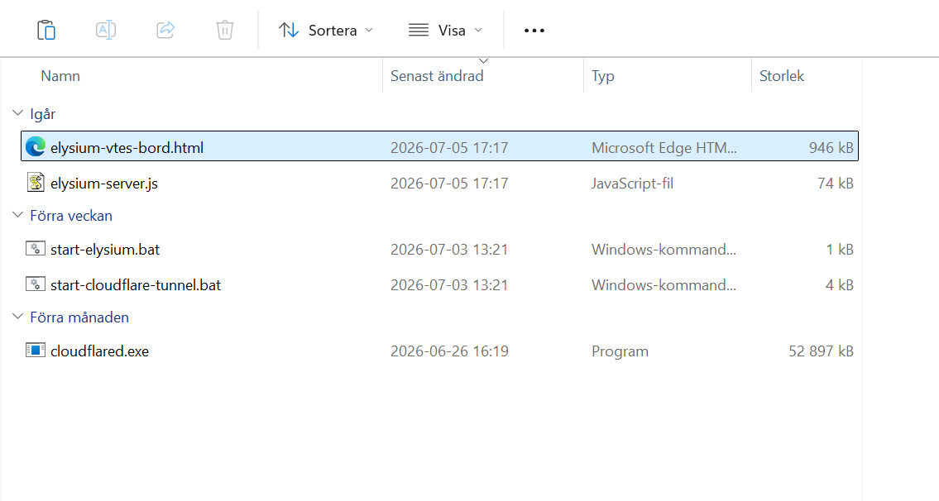
- Open start-elysium.bat to start the private server:

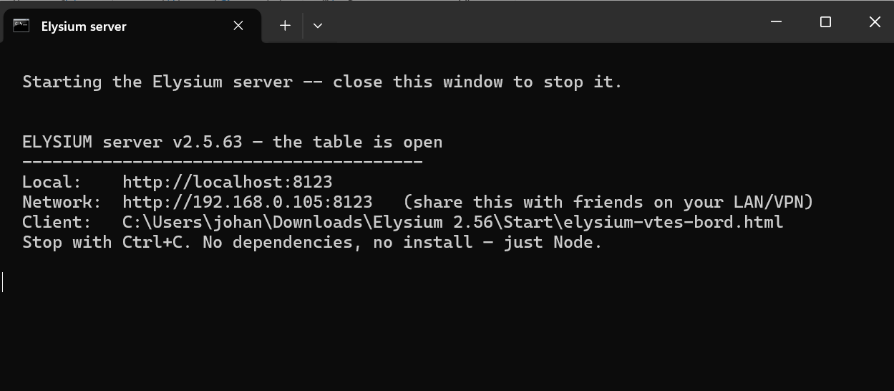

- Open elysium-vtes-board.html (Elysium game client). Click Play online to open the network window. Input the Network IP address above (i.e 192.168.0.105:8123 for example) in the Play online window in Elysium game client:

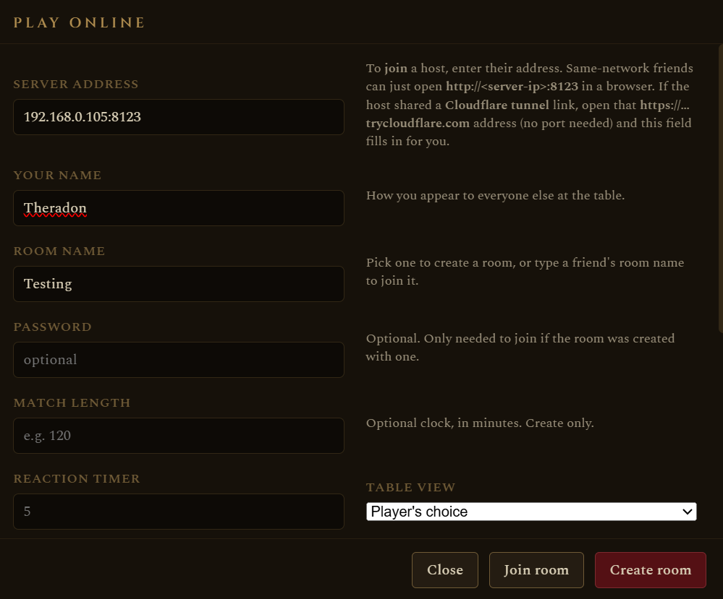

- Click Crate Room and you will enter the game lobby:

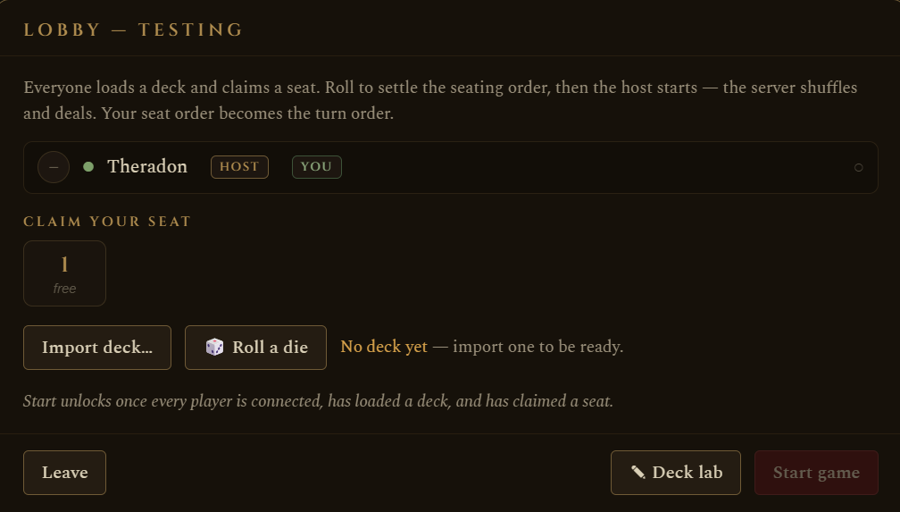

- Open start-cloudflared-tunnel.bat:
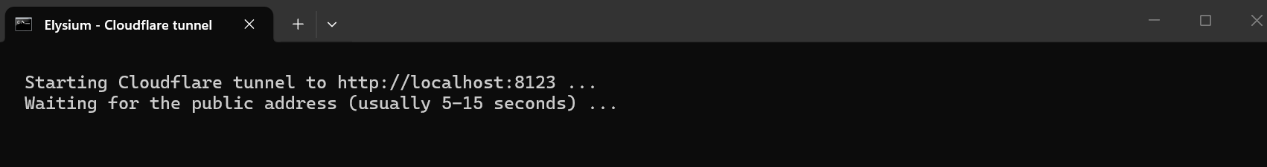
After a few moments you will also see this (along with alot of other stuff and maybe error messages of various kinds but don’t worry, it works anyway)
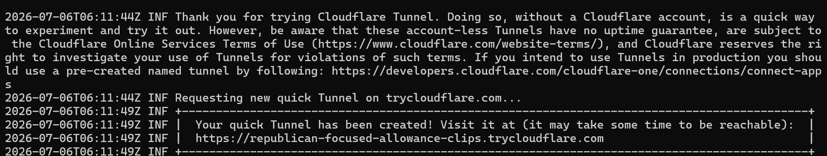
The tunnel address will be copied to your clipboard so you can immediately share it with our friends, for example:
https://republican-focused-allowance-clips.trycloudflare.com
- Your friends can put the link directly into their web browser and they will enter the Elysium game client:
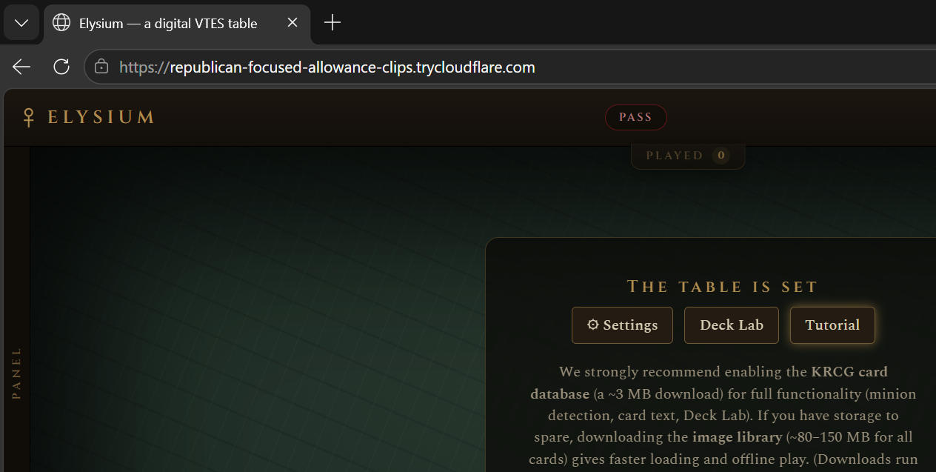
- When they click Play online the address has automatically been filled in so they only need to enter player name, room name, password etc:
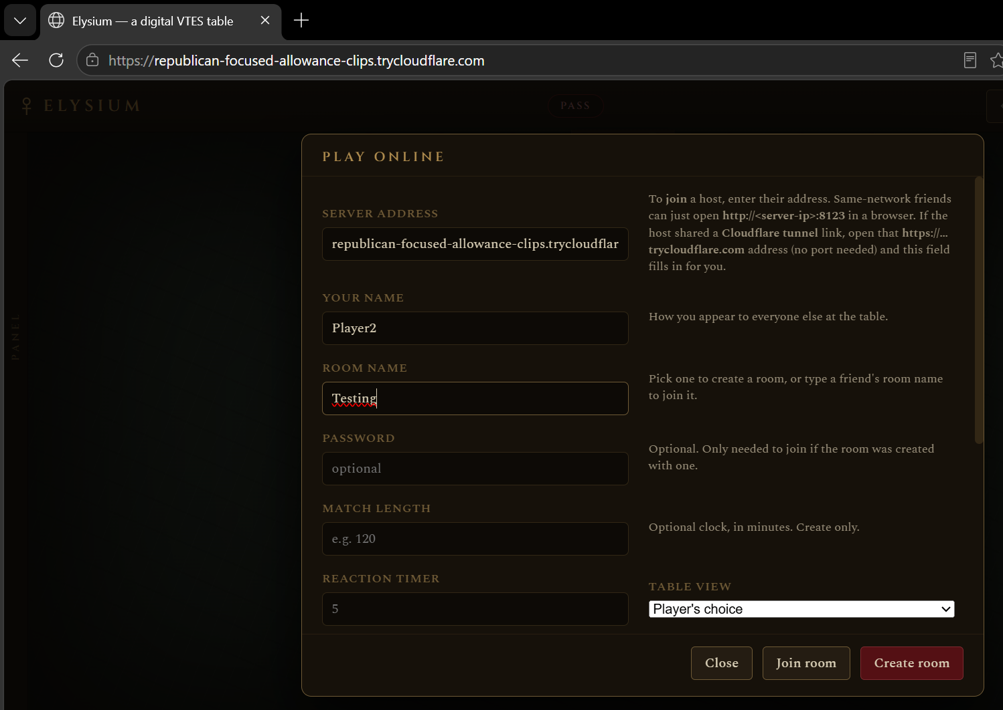

- Press Join room to enter the created room:
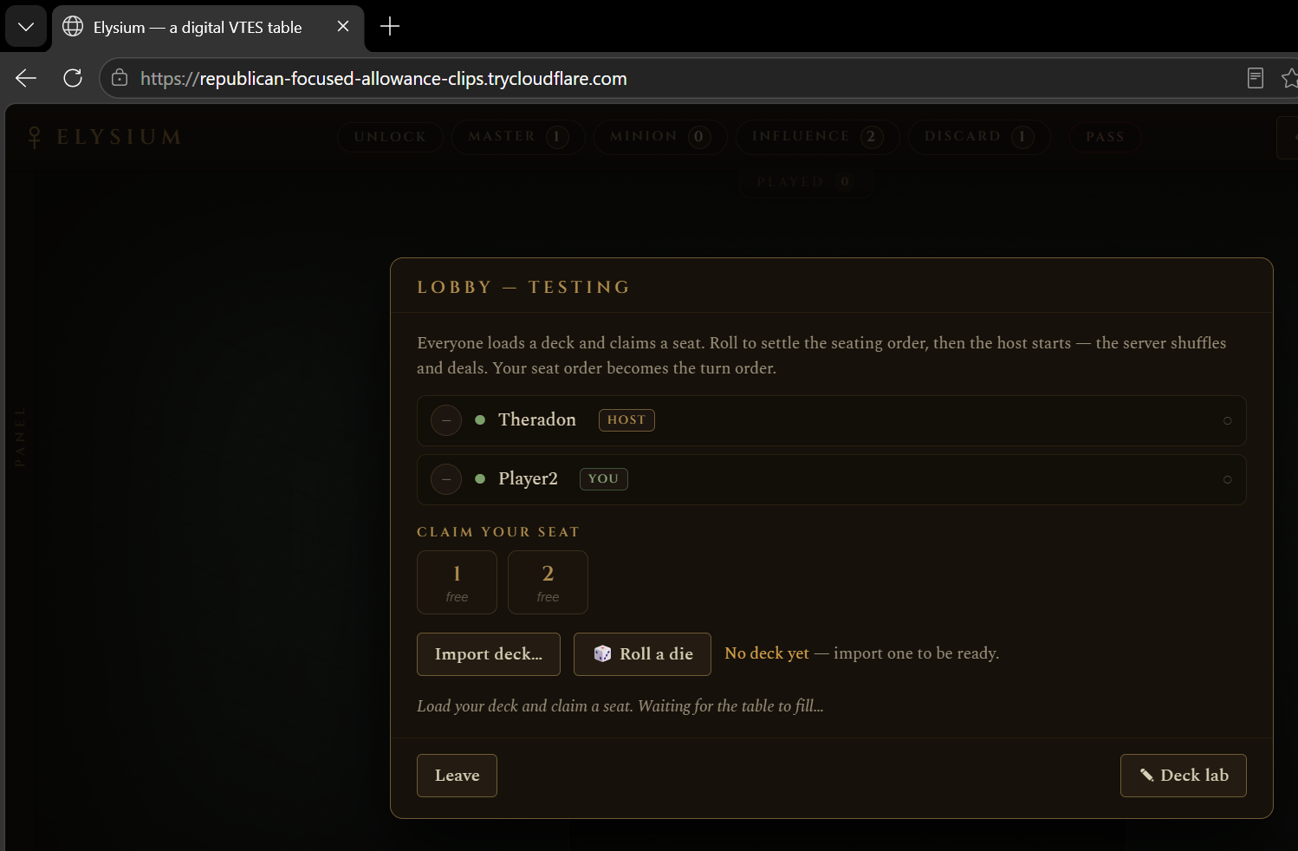
YOU ARE DONE!

Please note!
If you follow the weblink directly in a web browser, NONE of your previously saved settings or decks are stored since it’s a new entity you are entering. You can either:
- Save your settings and decks to .txt files and import them into new games after you have browsed to the link provided. KRCG card database must always be downloaded though (you probably skip downloading images when using this method).

- OR, your friends can download the game client beforehand and setup their preferred settings, decks and file options. When they join the room they do it by clicking Play online in the client file and filling in the web link address to join the game. If they do, all settings and saved decks and file downloads are stored locally and used for the session.

